

**ESOFT METRO CAMPUS KURUNEGALA**

**Corporate Division**

**FASHION HUT**

**(Web Site)**

*Author*

Pramod Jayathilaka

*Lecturer*

Mr.Nipuna Harshana

Registration No: 013434

Batch No. & Year: 021 / 2017

Submit Date: 2017/01/01



SUBMITED IN SUPPORT OF THE DIMPLOMA IN

WEB ENGINEERING

**DECLARATION**

I, the undersigned **Pramod Jayathilaka** student of the **Diploma in Web Engineering**, hereby declare that this project report titled **“Fashion Hut Web Site”** submitted to the Corporate Division, ESOFT Metro Campus, Kurunegala is record of original work done by me under the guidance of **Mr.Nipuna Harshana.**

The information and data given in the report is authentic to the best of my knowledge.

This Project Report is not submitted to any other university or institution for the award of any degree, diploma or fellowship or published any time before.

…………………………….. ….………………………

Student’s Signature Date

…………………………….. ….………………………

Lecturer’s Signature Date

…………………………….. ….………………………

ESOFT Manager’s Signature Date

**TABLE OF CONTENTS**

CHAPTER 1 INTRODUCTION 4

CHAPTER 2 Implementation 5

2.1 Development Tools & Technologies 5

2.2 PHP & HTML Implementation 5

2.2.1 Database Connection 5

2.2.2 Create Ads Form 6

2.2.3 Register Form 8

2.2.4 Login Form 10

2.2.5 Order Form 12

2.2.6 Ads Preview Source Code 15

2.3 Database Implementation 16

2.3.1 Create-add table 16

2.3.2 Member-registration table 17

2.3.3 Order table 18

# INTRODUCTION

The Internet has become an integral part of the world today. Because most goods and services are sold online. In the world today, many people use the Internet. They are very busy, so they order from products and services from home. To do that, businesses need a website. This website is also a commercial website that sells merchandise to advertise such items.

# Implementation

## Development Tools & Technologies

Adobe Dream viewer CS6

Workbench

XAMP Server

## PHP & HTML Implementation

### Database Connection

Source code of the database connection class

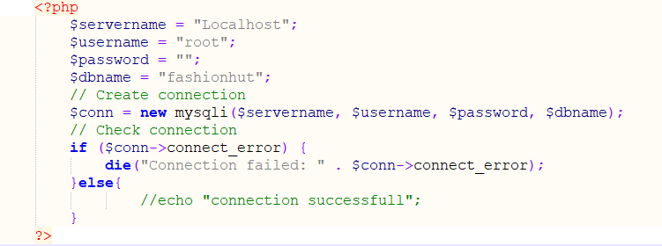

### Create Ad Form

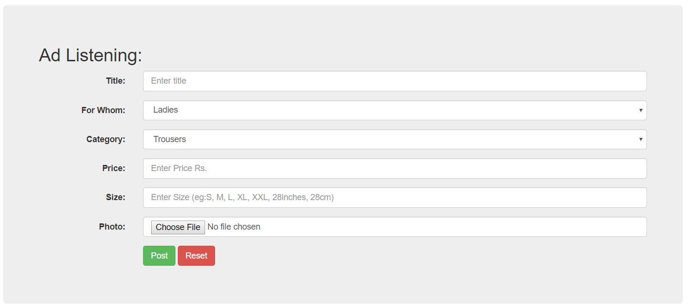

Crate Ad Form

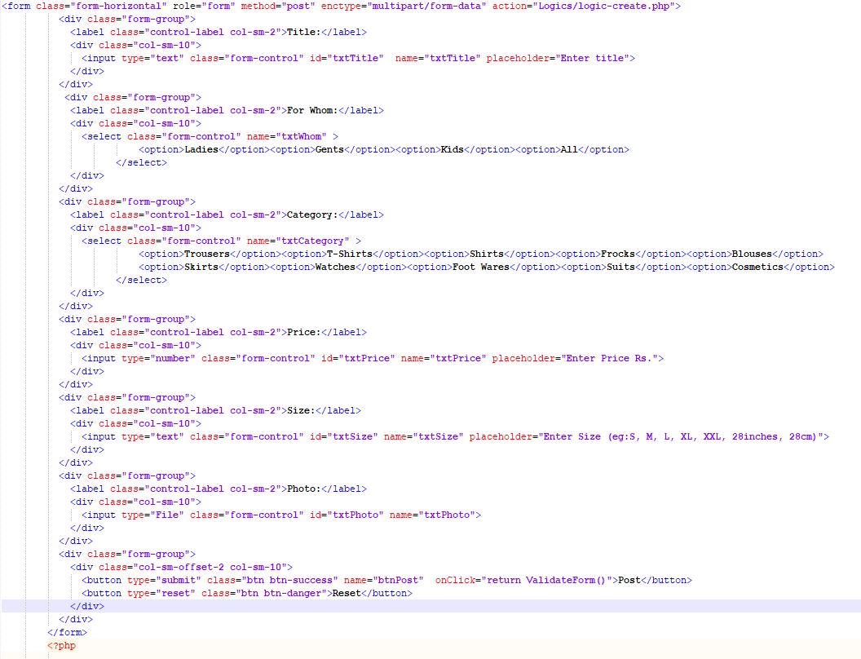

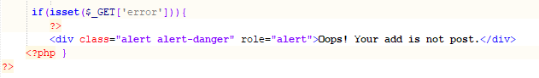

Source code for create ad form

### 

Logic of create ad form

### Register Form

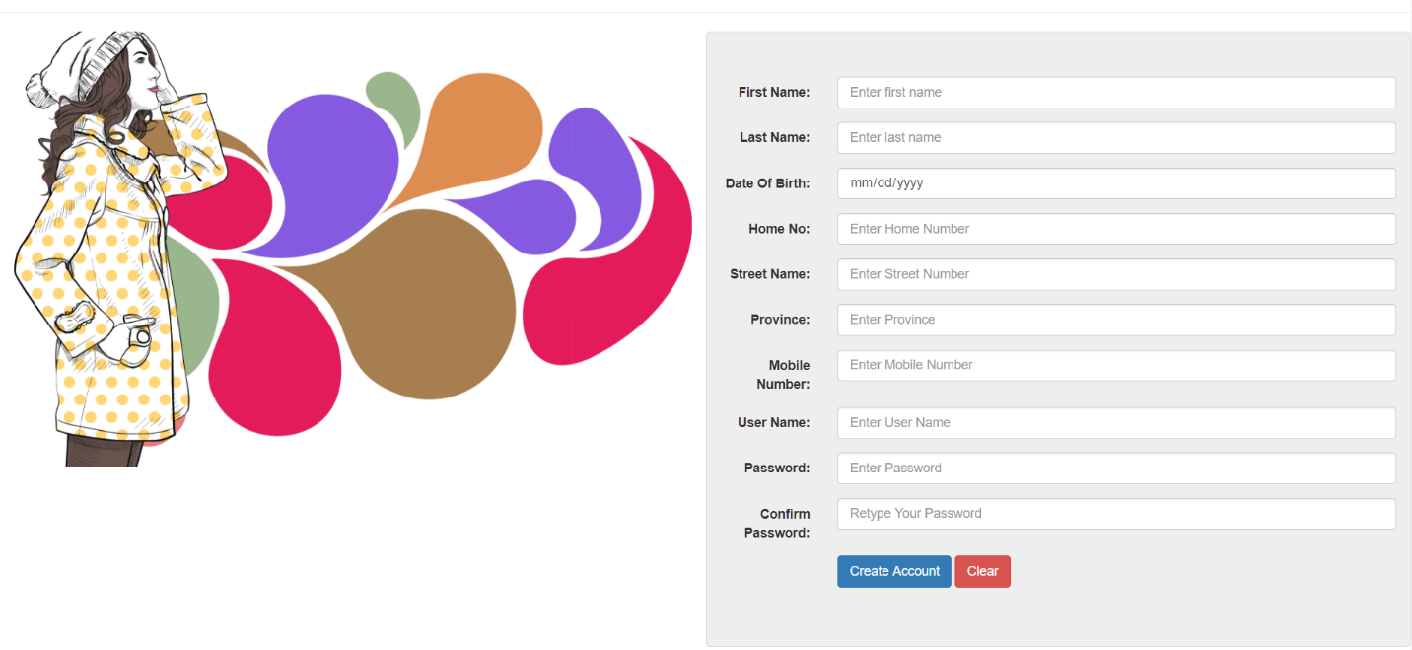

Register Form

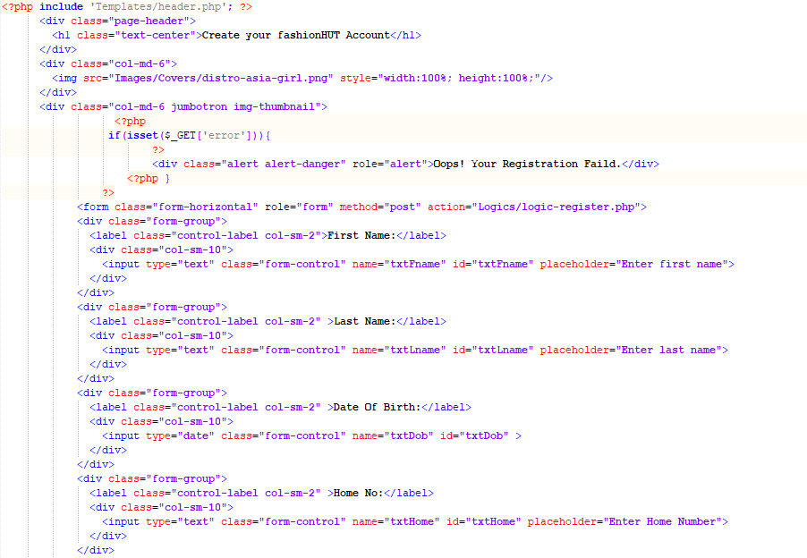

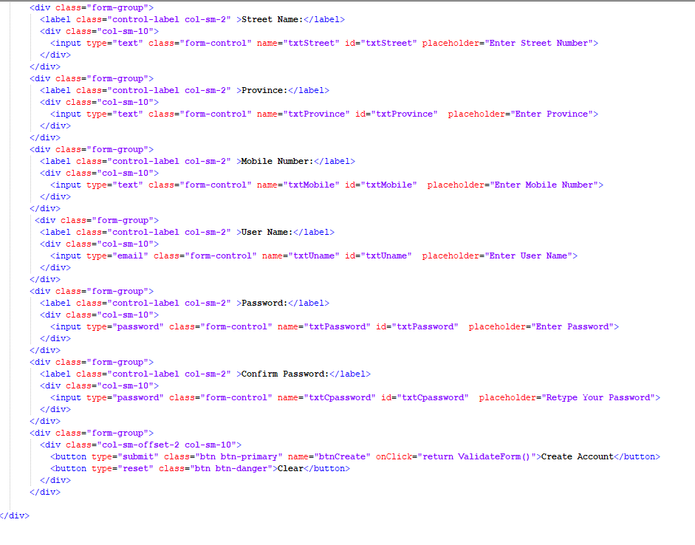

Source code for register form

## 

Logic of register form

### Login Form

Login Form

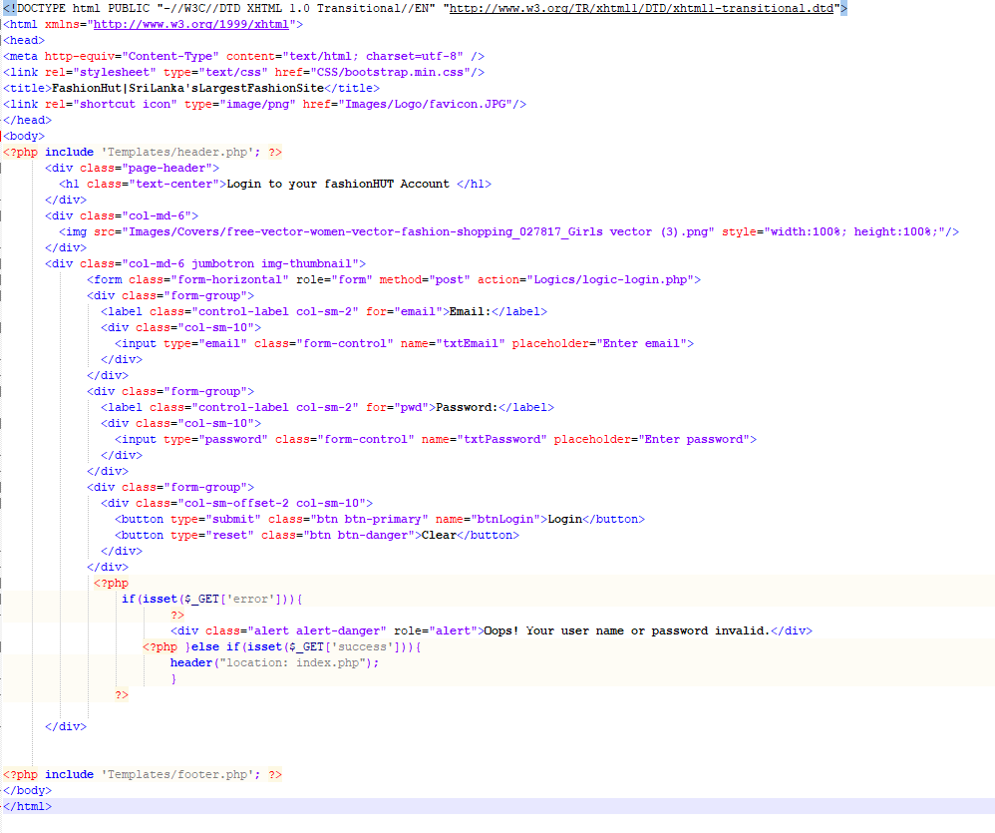

Source code for login form

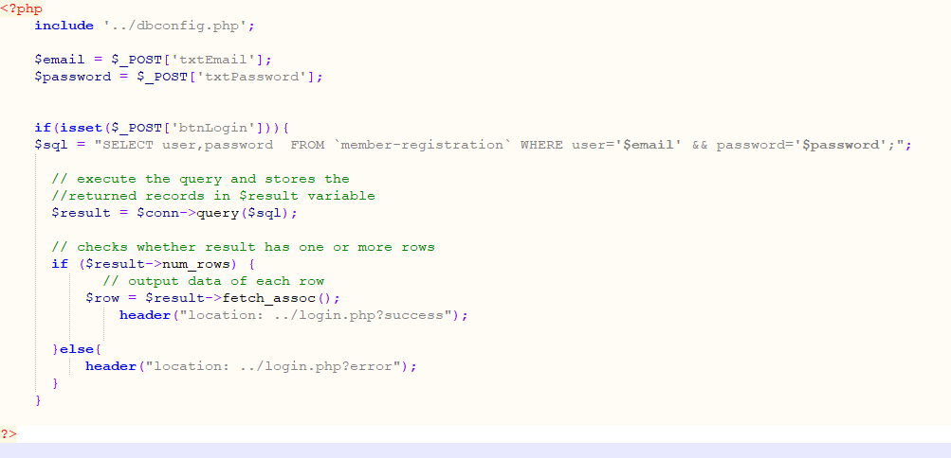

Logic of login form

### Order Form

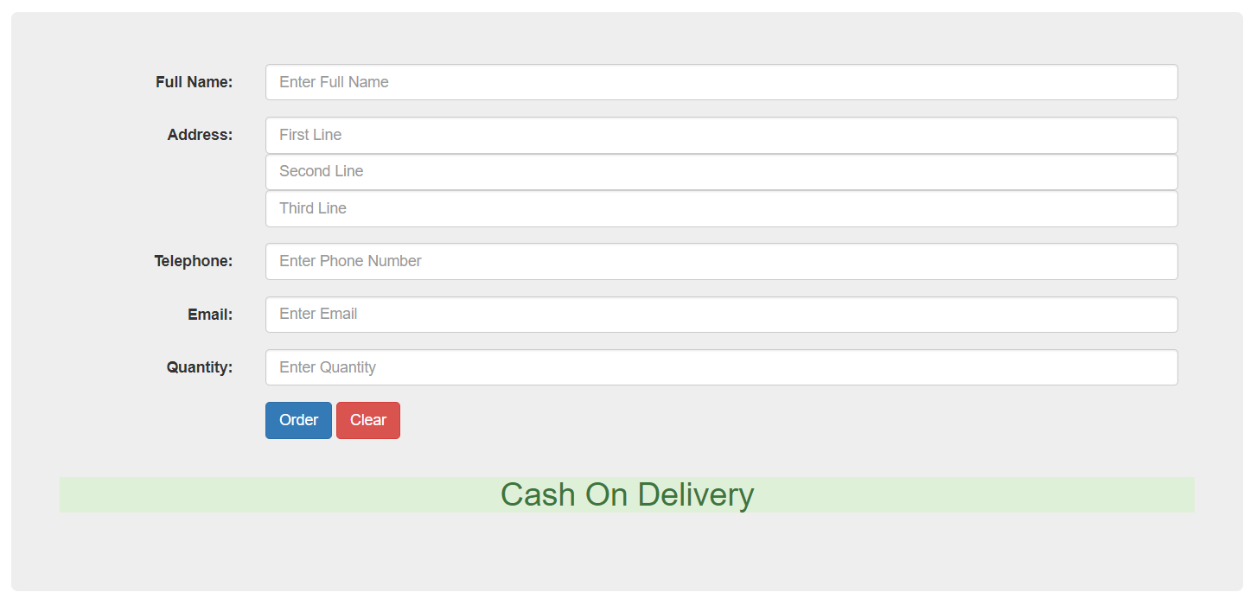

Order Form

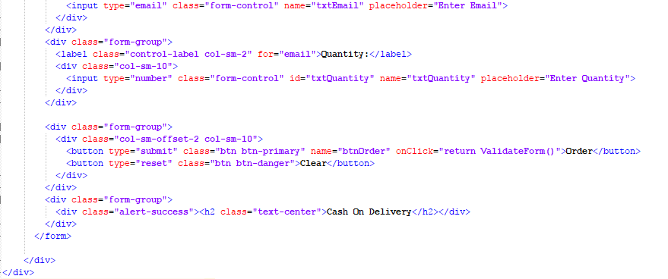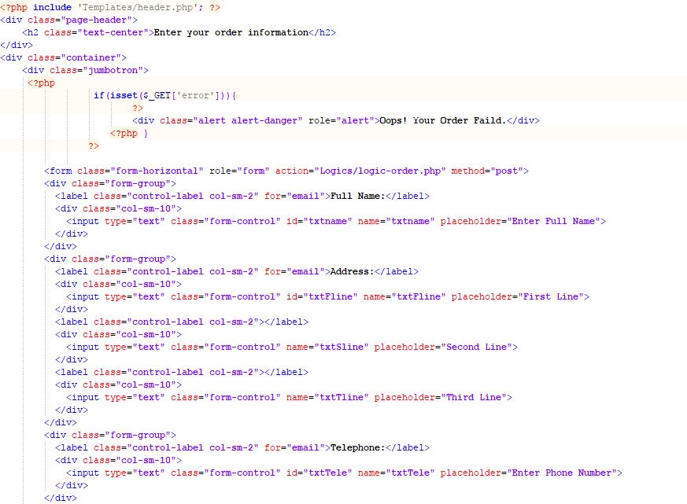

Source code for order form

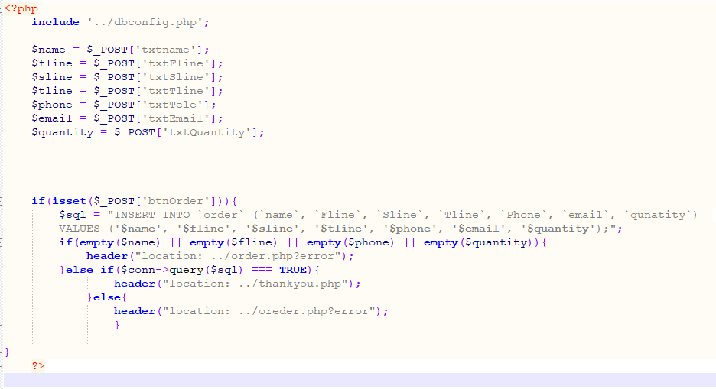

Logic of order form

### Adds preview source code

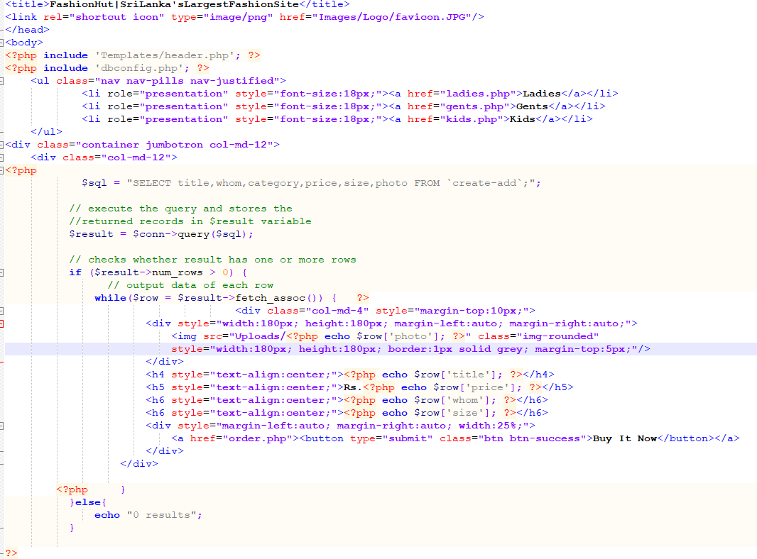

Source code for all ads

## Database Implementation

### Create-add table

Create query for create-add table

CREATE TABLE `fashionhut`.`create-add` (

`idcreate-add` INT(11) NOT NULL,

`title` VARCHAR(50) NULL,

`whom` VARCHAR(10) NULL,

`category` VARCHAR(15) NULL,

`price` INT(11) NULL,

`size` VARCHAR(20) NULL,

`photo` VARCHAR(200) NULL,

PRIMARY KEY (`idcreate-add`));

### Member-registration table

CREATE TABLE `fashionhut`.`member-registration` (

`idmember-registration` INT(11) NOT NULL,

`fname` VARCHAR(45) NULL,

`lname` VARCHAR(45) NULL,

`dob` DATE NULL,

`home` VARCHAR(45) NULL,

`street` VARCHAR(45) NULL,

`province` VARCHAR(30) NULL,

`mobile` VARCHAR(12) NULL,

`user` VARCHAR(50) NULL,

`password` VARCHAR(30) NULL,

PRIMARY KEY (`idmember-registration`));

Create query for member-registration table

### order table

CREATE TABLE `fashionhut`.`order` (

`order-id` INT(11) NOT NULL,

`name` VARCHAR(45) NULL,

`Fline` VARCHAR(45) NULL,

`Sline` VARCHAR(45) NULL,

`Tline` VARCHAR(45) NULL,

`Phone` VARCHAR(45) NULL,

`email` VARCHAR(45) NULL,

`quantity` INT(11) NULL,

PRIMARY KEY (`order-id`));